Why  Tai Chi?  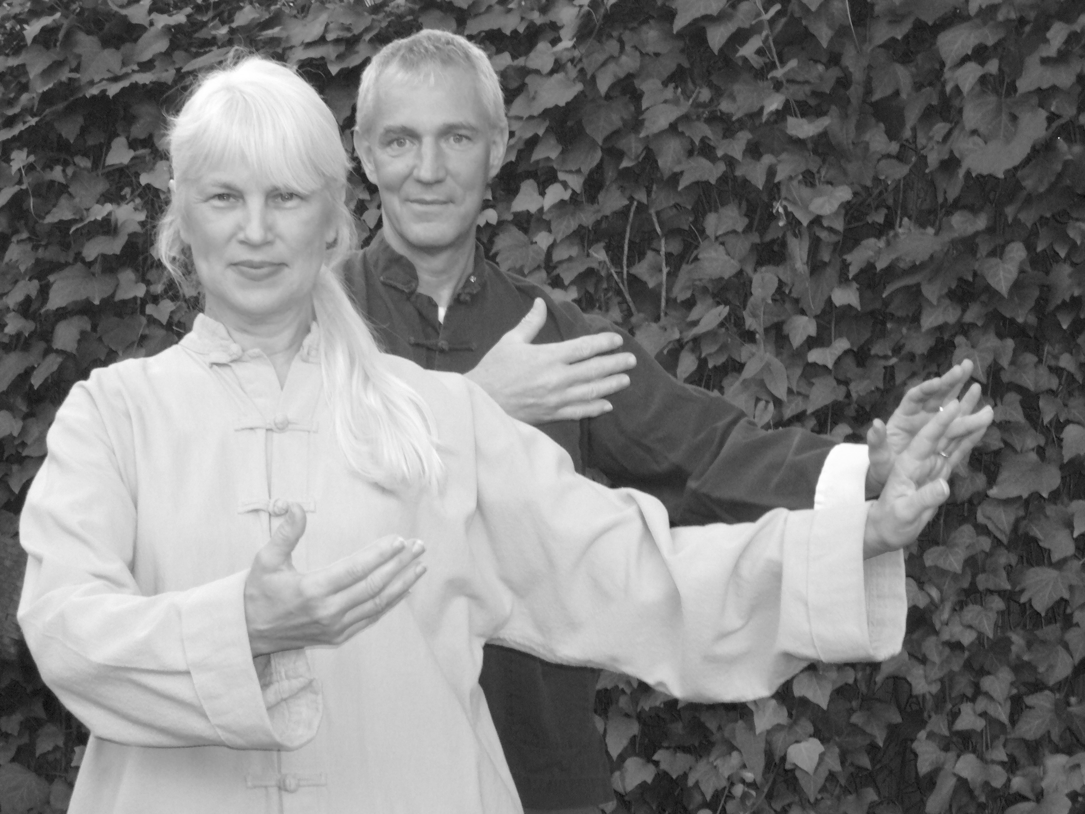  Tai Chi has been described, as preventive medicine at it’s best. The movements are designed to clear energy blockages in the body. Tai Chi is often prescribed by Oriental Medical Doctors to aid in the healing of chronic illnesses. The flowing Tai Chi movements are excellent exercise and are known to develop:  - Power & Grace  - Strength & Serenity  - Stress Relief & Energy Increase  - Focus & Concentration  . | Harvard University and the Mayo Clinic have written articles praising Tai Chi. Both cite scientific studies recognized by the AMA.  These studies say that practicing Tai Chi regularly may:  - Reduce anxiety and depression  - Improve balance and coordination, reducing the number of falls  - Improve sleep quality, such as staying asleep longer at night and feeling more alert during the day  - Slow bone loss in women following menopause  - Reduce high blood pressure  - Improve cardiovascular fitness  - Relieve chronic pain  - Improve everyday physical functioning  FREE SEMINAR: Tai Chi Instructor, Marjorie Jackson, is offering a FREE one-hour seminar to interested groups. The seminar is educational and experiential.  The seminar participants will have a chance to learn more deeply about this popular Chinese exercise. Seminar location can be yours or hers. | Marjorie Jackson and her husband, Danny Boone are instructors at their Austin Tai Chi School in Austin Texas. Their teaching style is relaxed, yet enthusiastic and lends to an enjoyable classroom experience. Their Tai Chi classes are for beginner, intermediate and advanced students.  Trained as instructors in Los Angeles at the internationally acclaimed Tai Chi Academy of Master Kai Ying Tung, Marjorie and Danny are among Master Tung’s senior advanced students. Marjorie has been teaching Tai Chi & Hatha Yoga for 18 years.  For their Tai Chi lineage see:  www.tungkaiying.com  See the website for the schedule of evening and morning classes in south, central, north central and northwest Austin.  Call Marjorie Jackson  for information and to RSVP  (512) 916-8919  www.AustinTaiChi.com  Marjorie Jackson & Danny Boone  (512) 420-9412  www.austintaichi.com

